1. Mathematical Expression for the Model
The model output$y^{​}\left(x\right)$is computed using a set of Gaussian basis functions:
$$\hat{y}\left(x\right)=\sum_{j=1}^{M}{w_{j}ϕ_{j}\left(x\right)}$$
where:
- $wj​$ are the model weights.
- $ϕj​(x)$ are the Gaussian basis functions cantered at the cluster centres
Each basis function $ϕj​(x)$ is computed as:
$$ϕ_{j}\left(x\right)=\exp\left(-\frac{|x-μ_{j}|^{2}}{S}\right)$$
where:
- x is the input data point.
- $μj​$ is the center of the j-th basis function.
- S is the scale factor, calculated as:
$$S=\frac{\max_{i,j}{|}μ_{i}-μ_{j}|^{2}}{\sqrt{2M}}$$

2. Model Complexity

- Interpretation: With M=2, the model uses two Gaussian basis functions, meaning it has low complexity and relatively limited capacity to fit complex patterns in the data. This setup is beneficial for preventing overfitting, especially for small datasets, but it can also lead to underfitting for more complex data.

3. Regularization Parameter λ
- Regularization helps prevent overfitting by adding a penalty to the model's weights, discouraging large values and thereby smoothing the model. The regularization term λ modifies the loss function as follows:
$$\text{Loss}=\frac{1}{N}\sum_{i=1}^{N}{{\left(y_{i}-\hat{y_{i}}\right)}^{2}}+λ\sum_{j=1}^{M}{w_{j}^{2}}$$
Where:
- $\frac{1}{N}\sum_{i=1}^{N}{{\left(y_{i}-\hat{y_{i}}\right)}^{2}}$ is the mean squared error (MSE) on the training set.
- $λ\sum_{j=1}^{M}{w_{j}^{2}}$ is the regularization term (also called the Ridge penalty or L2 norm), with $λ$ controlling the strength of regularization.
- $w_{j}$ are the model's weights associated with each basis function.
As λ increases, the model is penalized more for having large weights, which tends to smooth out the function and reduce overfitting.

Inferences from Each Plot:

- Regularization $λ=0$ (No Regularization)

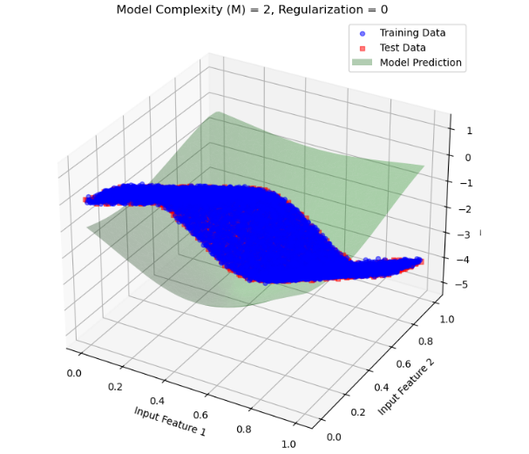
1 figure
- Observation: With no regularization, the model tries to fit the data as closely as possible based on the training data. This can lead to overfitting, where the model captures noise in the training set.
- Impact: Since M=2 provides limited flexibility, the model might not fully overfit, but there is still a risk. The lack of a regularization penalty allows the model’s weights to take values that closely align with the training data, potentially deviating on the test data.
- Conclusion: Without regularization, the model is more prone to overfitting, especially if we increase MMM to a higher complexity.

- Regularization λ=0.001 (Low Regularization)
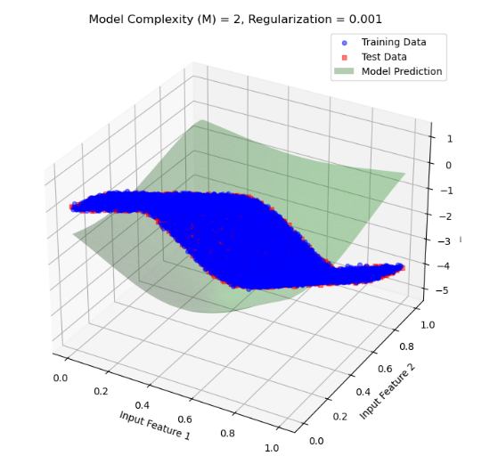
2 figure
- Observation: Introducing a small amount of regularization slightly constrains the model's weights. The model becomes a bit smoother, as the regularization penalty discourages extreme weight values.
- Impact: This small regularization helps reduce overfitting by preventing the model from conforming too closely to the training data. The model’s generalization capability on the test data improves slightly as it is not as susceptible to capturing noise in the training set.
- Conclusion: Low regularization reduces some of the overfitting tendency without significantly impacting the fit on the training data.
- Regularization λ=0.01 (Moderate Regularization)
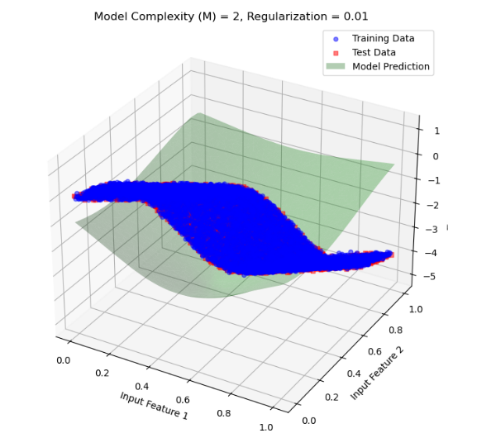
3figure
- Observation: With a higher regularization parameter, the model weights are further penalized, resulting in a smoother approximation function. The model avoids extreme values for the weights, leading to a more balanced fit.
- Impact: The model begins to generalize better, with reduced overfitting. The fit to the test data improves, showing that the model is effectively avoiding noise in the training data.
- Conclusion: Moderate regularization strikes a balance, reducing overfitting while maintaining a good approximation of the training data.
- Regularization λ=0.1(High Regularization)
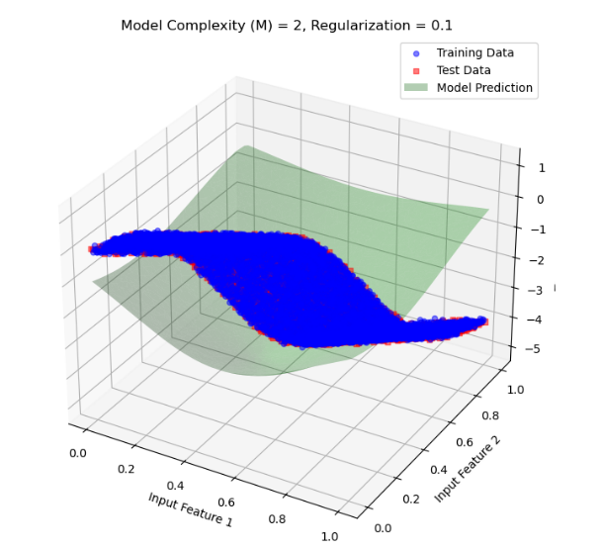
4figure
- Observation: As regularization increases further, the model becomes even smoother, and the weights are restricted even more. This higher regularization leads to a more conservative model, which avoids making overly confident predictions based on training data alone.
- Impact: At this level, the model's generalization on the test set is better, but it may start to slightly underfit the training data due to the high regularization penalty.
- Conclusion: High regularization reduces overfitting significantly, but if increased further, it risks underfitting.
- Regularization λ=1(Very High Regularization)

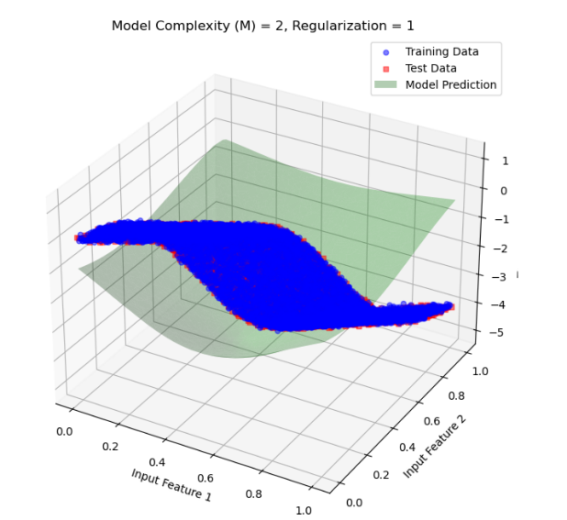
- Observation: At this point, the regularization is very strong, heavily penalizing large weights and forcing the model to produce a very smooth function. The model now approximates a very simplistic trend in the data.
5figure
- Impact: The model may start to underfit, as the high regularization limits its ability to capture even genuine trends in the data. The test and training errors may increase slightly as the model fails to represent underlying data patterns.
- Conclusion: Very high regularization prevents overfitting completely but can lead to underfitting, where the model cannot adequately capture patterns in the data.

Conclusion
The plots demonstrate the trade-off between overfitting and underfitting:
- Overfitting: Seen with lower regularization values, where the model adheres closely to the training data, capturing noise and reducing generalization ability.
- Underfitting: Occurs with very high regularization, where the model becomes too simplistic, failing to capture genuine patterns in the data.

Interpretation: With Model Complexity M=4, the model uses four Gaussian basis functions. This increased complexity allows the model to capture more intricate patterns in the data, which can improve its performance. However, with low or no regularization, this also increases the risk of overfitting as the model tries to fit noise in the training data.

Inferences from Each Plot:
- Regularization λ=0 (No Regularization)
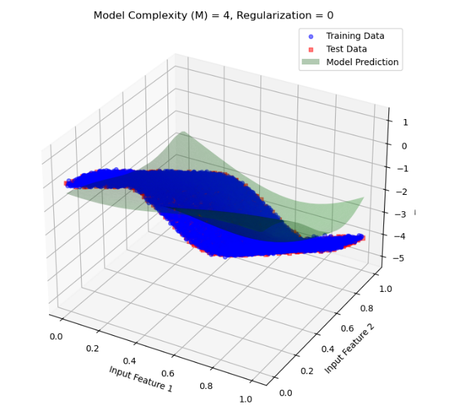
6figure
- Observation: With no regularization, the model tries to fit the data as closely as possible based on the training data. This can lead to overfitting, where the model captures noise in the training set.
- Impact: Since M=4 provides limited flexibility, the model might not fully overfit, but there is still a risk. The lack of a regularization penalty allows the model’s weights to take values that closely align with the training data, potentially deviating on the test data.
- Conclusion: Without regularization, the model is more prone to overfitting, especially if we increase MMM to a higher complexity.
- Regularization λ=0.001 (Low Regularization)
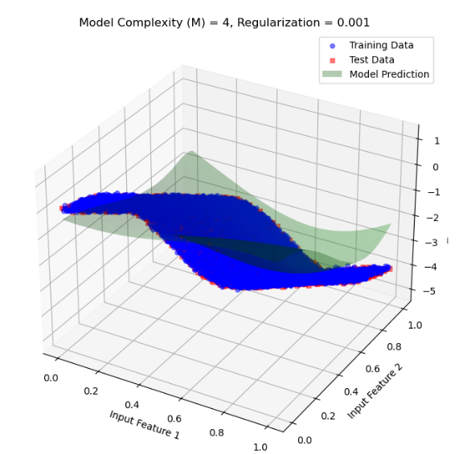
7figure
- Observation: Introducing a small amount of regularization slightly constrains the model's weights. The model becomes a bit smoother, as the regularization penalty discourages extreme weight values.
- Impact: This small regularization helps reduce overfitting by preventing the model from conforming too closely to the training data. The model’s generalization capability on the test data improves slightly as it is not as susceptible to capturing noise in the training set.
- Conclusion: Low regularization reduces some of the overfitting tendency without significantly impacting the fit on the training data.
- Regularization λ=0.01 (Moderate Regularization)
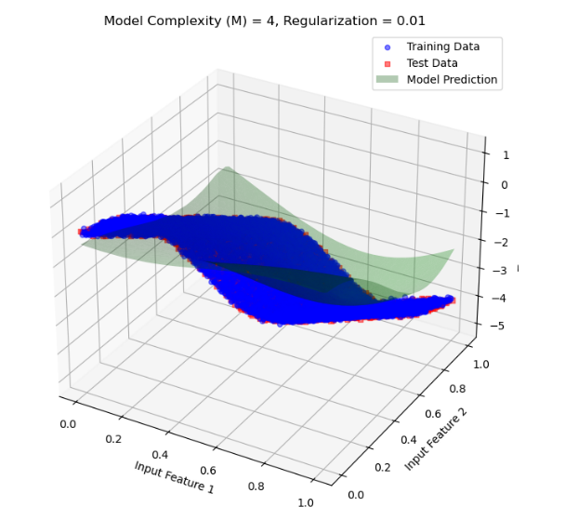
8figure
- Observation: With a higher regularization parameter, the model weights are further penalized, resulting in a smoother approximation function. The model avoids extreme values for the weights, leading to a more balanced fit.
- Impact: The model begins to generalize better, with reduced overfitting. The fit to the test data improves, showing that the model is effectively avoiding noise in the training data.
- Conclusion: Moderate regularization strikes a balance, reducing overfitting while maintaining a good approximation of the training data.

- Regularization λ=0.1 (High Regularization)
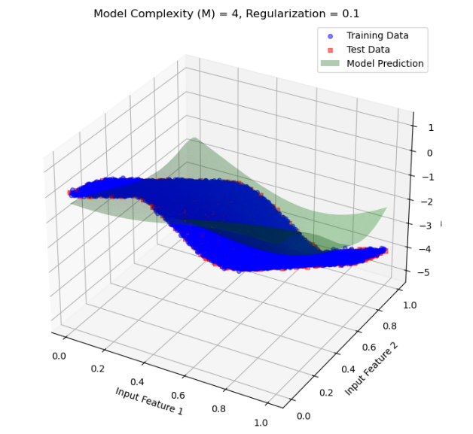
9figure
- Observation: As regularization increases further, the model becomes even smoother, and the weights are restricted even more. This higher regularization leads to a more conservative model, which avoids making overly confident predictions based on training data alone.
- Impact: At this level, the model's generalization on the test set is better, but it may start to slightly underfit the training data due to the high regularization penalty.
- Conclusion: High regularization reduces overfitting significantly, but if increased further, it risks underfitting.
- Regularization λ=1 (Very High Regularization)
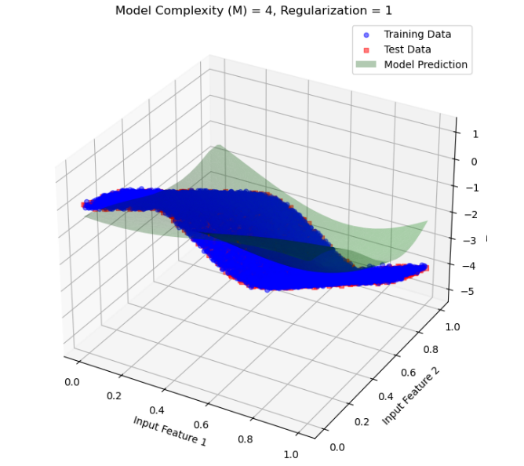
10figure
- Observation: At this point, the regularization is very strong, heavily penalizing large weights and forcing the model to produce a very smooth function. The model now approximates a very simplistic trend in the data.
- Impact: The model may start to underfit, as the high regularization limits its ability to capture even genuine trends in the data. The test and training errors may increase slightly as the model fails to represent underlying data patterns.
- Conclusion: Very high regularization prevents overfitting completely but can lead to underfitting, where the model cannot adequately capture patterns in the data.
Interpretation: With Model Complexity M=8, the model employs eight Gaussian basis functions. This higher complexity allows the model to capture finer details in the data, potentially enhancing its performance. However, without adequate regularization, this complexity can lead to overfitting as the model may attempt to capture noise in the training data.

Inferences from Each Plot:
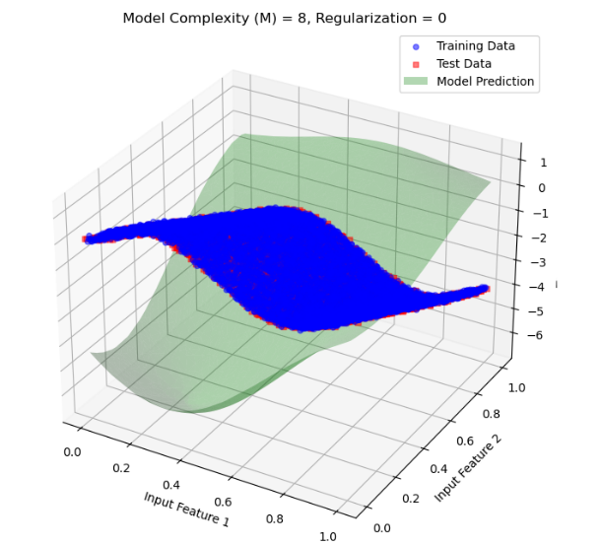
- Regularization λ=0 (No Regularization)
11figure

- Mathematical Expression:
$$\text{Loss}=\frac{1}{N}\sum_{i=1}^{N}{{\left(y_{i}-\hat{y_{i}}\right)}^{2}}$$
- Observation: Without regularization, the model is free to fit the training data as closely as possible. Given the high complexity of M=8, the model can overfit significantly, capturing noise and small variations in the training data. This often leads to poor performance on the test data due to the model's sensitivity to noise.
- Conclusion: Without regularization, the model overfits, showing high variance on test data. The model does well on training data but fails to generalize.

- Regularization λ=0.001 (Low Regularization)
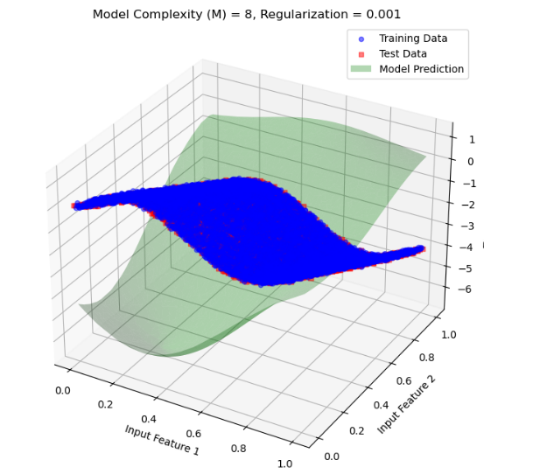
12figure
  - Mathematical Expression:
$$\text{Loss}=\frac{1}{N}\sum_{i=1}^{N}{{\left(y_{i}-\hat{y_{i}}\right)}^{2}}+0.001\sum_{j=1}^{M}{w_{j}^{2}}$$
- Observation: A small regularization term introduces a slight constraint on the weights, which smooths the model slightly and mitigates overfitting. The model's performance on the test set improves, as it becomes less sensitive to training noise.
- Conclusion: Low regularization reduces overfitting to some extent, improving test set generalization without overly restricting the model's flexibility.
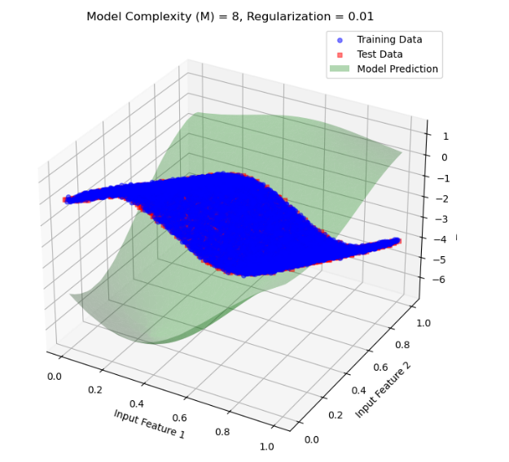
- Regularization λ=0.01 (Moderate Regularization)
13figure

- Mathematical Expression:
$$\text{Loss}=\frac{1}{N}\sum_{i=1}^{N}{{\left(y_{i}-\hat{y_{i}}\right)}^{2}}+0.01\sum_{j=1}^{M}{w_{j}^{2}}$$
- Observation: With moderate regularization, the model smooths out further, resulting in a balanced fit. This level of regularization effectively reduces overfitting, allowing the model to generalize better on the test data while still capturing important data trends.
- Conclusion: Moderate regularization effectively reduces overfitting, providing a balanced model that generalizes well on the test data.

- Regularization λ=0.1 (High Regularization)
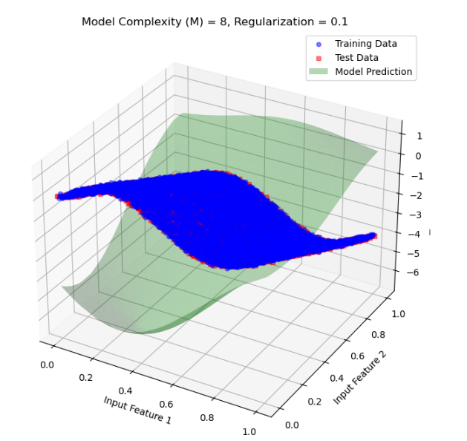
14figure
  - Mathematical Expression:
$$\text{Loss}=\frac{1}{N}\sum_{i=1}^{N}{{\left(y_{i}-\hat{y_{i}}\right)}^{2}}+0.1\sum_{j=1}^{M}{w_{j}^{2}}$$
- Observation: With high regularization, the model is more constrained. This results in a smoother function that reduces overfitting further but may risk underfitting. The model’s flexibility is limited, which could prevent it from capturing more intricate patterns in the data.
- Conclusion: High regularization effectively mitigates overfitting, but the model may start to underfit the data as it loses some ability to adapt to complex patterns.

- Regularization λ=1 (Very High Regularization)
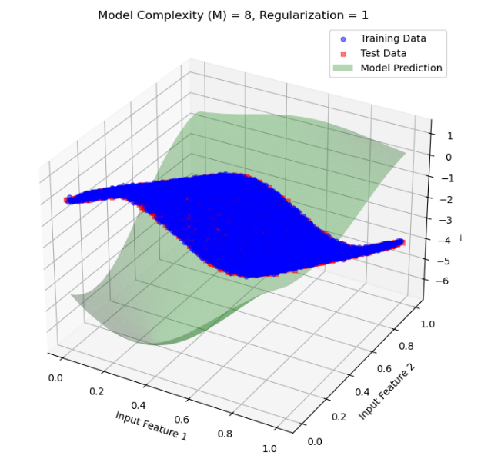
15figure
  - Observation: Very high regularization forces the model to heavily constrain the weights, leading to a very smooth and simplistic model that may underfit the data. While it avoids overfitting, it fails to capture important data trends due to the strong regularization.
  - Conclusion: Very high regularization prevents overfitting completely but results in underfitting, as the model is overly simplified and cannot capture the underlying data structure effectively.

Interpretation: With Model Complexity M=16, the model uses sixteen Gaussian basis functions, giving it a high capacity to fit complex data structures. Without adequate regularization, this complexity can lead to significant overfitting as the model tries to capture even the smallest fluctuations in the training data.

Inferences from Each Plot:
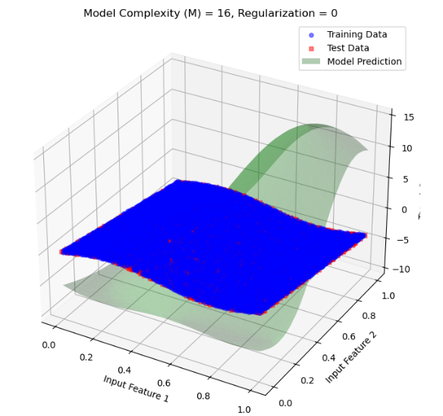
- Regularization λ=0 (No Regularization)
16figure

  - Observation: With no regularization, the model has maximum freedom to fit the data. Given the high complexity M=16, the model likely overfits, capturing noise and minor variations in the training data. This often results in poor generalization on the test data.
- Conclusion: Without regularization, the model is overfitted, capturing fluctuations in the training data that do not generalize well to new data.

- Regularization λ=0.001 (Low Regularization)
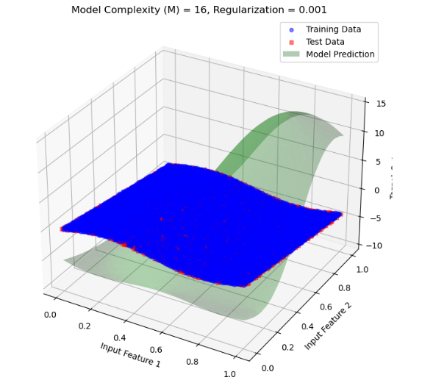
17figure
- Observation: A small regularization term introduces a slight constraint on the weights, which slightly reduces overfitting. The model’s performance on the test data improves as it becomes less sensitive to noise in the training data.
- Conclusion: Low regularization mitigates overfitting to some extent, resulting in a model that generalizes slightly better while still capturing meaningful patterns in the data.

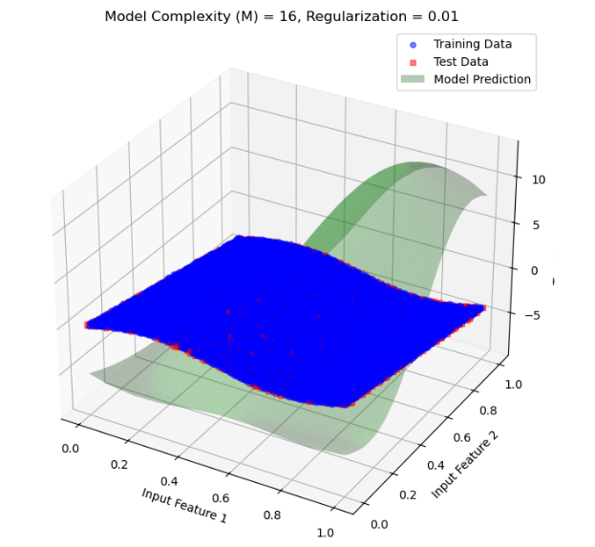
- Regularization λ=0.01 (Moderate Regularization)
18figure

- Observation: Moderate regularization smooths the model further, allowing it to balance between fitting the data well and reducing overfitting. This results in a model that generalizes well on the test data without being overly complex.
- Conclusion: Moderate regularization provides a balance between flexibility and smoothness, resulting in better generalization on unseen data.

- Regularization λ=0.1 (High Regularization)
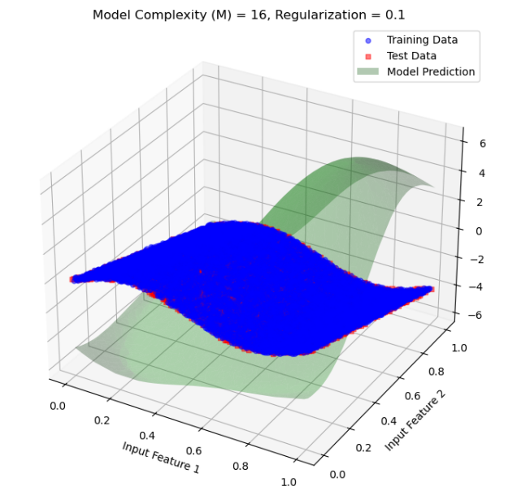
19figure
- Observation: With high regularization, the model is constrained further, resulting in a much smoother function. While this helps in reducing overfitting, it may start to underfit if the regularization is too strong relative to the model complexity.
- Conclusion: High regularization reduces overfitting significantly but may begin to lose flexibility, which could limit the model's ability to capture subtle patterns in the data.

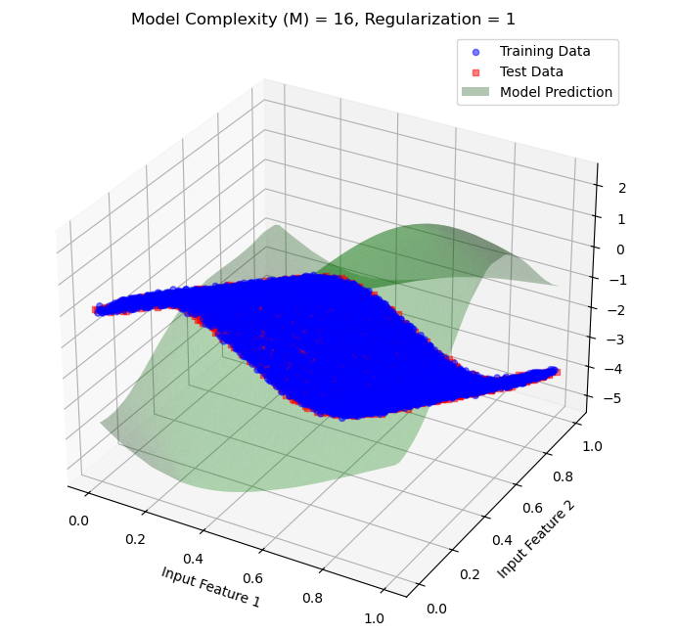
- Regularization λ=1 (Very High Regularization)
20figure

- Observation: Very high regularization forces the model to constrain its weights considerably, leading to a very simple model that may underfit the data. While it prevents overfitting, it loses the capacity to model meaningful trends, impacting performance on both the training and test data.
- Conclusion: Very high regularization results in underfitting, as the model is oversimplified and fails to capture essential patterns in the data.

Interpretation: For model complexity M=32 with various regularization values, let's analyse how the high complexity model behaves with and without regularization. This complexity level has a substantial number of basis functions, which allows for high flexibility but also poses a significant risk of overfitting if not carefully regularized.

Inferences from Each Plot:
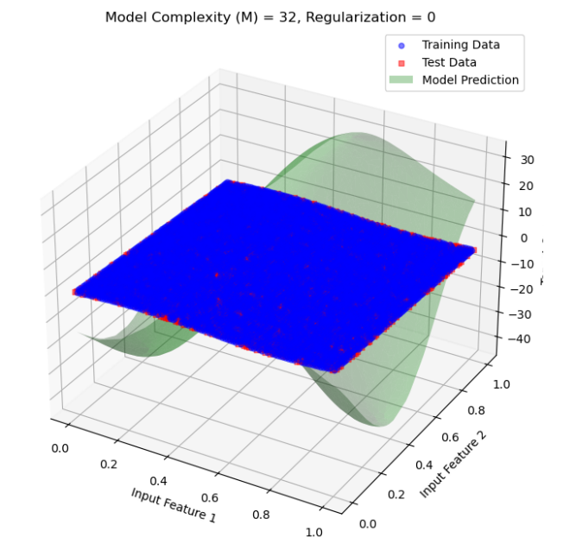
1.Regularization λ=0 (No Regularization)
21figure

- Observation: With no regularization, the model attempts to fit the training data as closely as possible. Due to the high complexity M=32, the model is prone to severe overfitting, capturing noise and small fluctuations in the training data. This leads to very poor generalization on test data.
- Conclusion: Without regularization, the model significantly overfits. It has high variance and performs poorly on test data, indicating a failure to generalize.

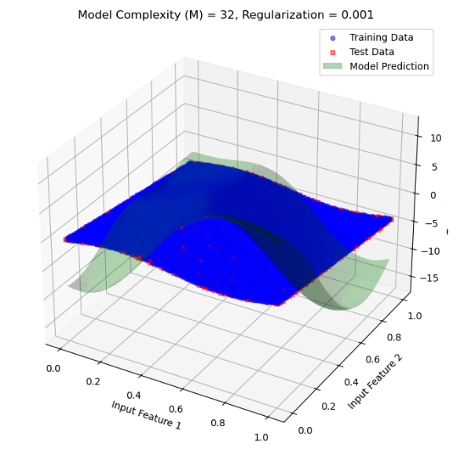
- Regularization λ=0.001 (Low Regularization)
22figure

- Observation: A small regularization penalty reduces some of the overfitting by imposing a minor constraint on the model’s weights. The model is still quite flexible, but it generalizes somewhat better to the test data.
- Conclusion: Low regularization helps reduce overfitting slightly. The model can capture significant trends but may still overfit on the training data, given the high complexity of the model.

- Regularization λ=0.01 (Moderate Regularization)
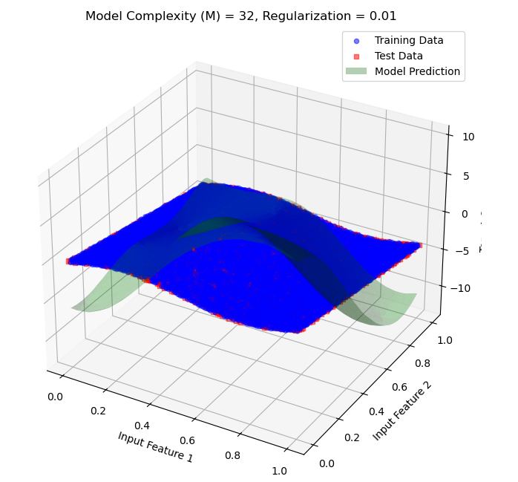
23figure
- Observation: With moderate regularization, the model achieves a better balance between fitting the training data and generalizing to the test data. This regularization level smooths the model enough to reduce the risk of overfitting while still allowing it to capture key patterns.
- Conclusion: Moderate regularization provides a reasonable balance between flexibility and smoothness, leading to better generalization.

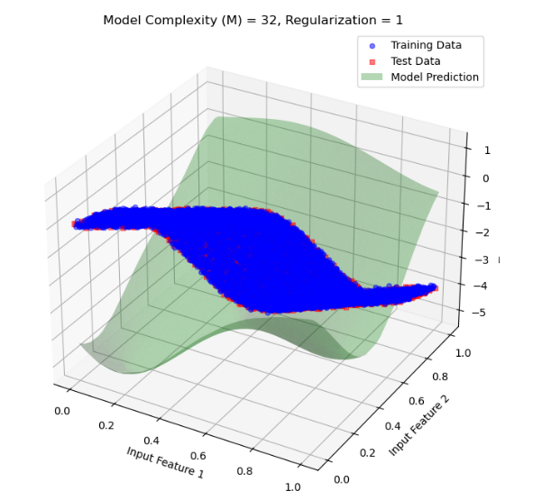
- Regularization λ=1 (Very High Regularization)
24figure

- Observation: Very high regularization overly restricts the model, causing it to become too simple. It fails to capture essential data patterns, resulting in underfitting and poor performance on both training and test data.
- Conclusion: Very high regularization leads to underfitting as the model becomes too constrained to capture the complexity of the data.

Interpretation: With 128 basis functions, the model has a very high capacity to fit complex patterns within the data. However, this level of complexity also makes the model susceptible to severe overfitting, where it may capture noise or irrelevant variations within the training data unless controlled by regularization.

Inferences from Each Plot:

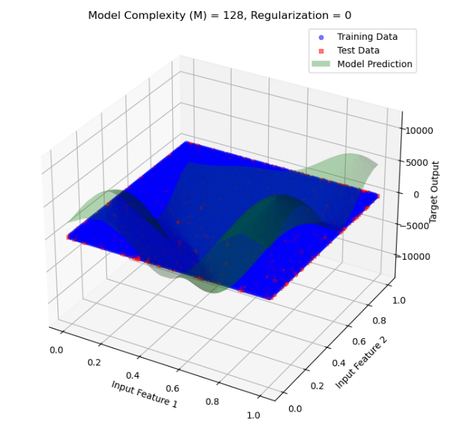
1.Regularization λ=0 (No Regularization)
25figure

- Observation: Without regularization, the model overfits severely. With 128 basis functions, it captures noise and irrelevant details in the training data, causing erratic predictions on unseen test data. The result is a poor generalization, as evidenced by large prediction errors in the test dataset.
- Conclusion: At M=128 ,without regularization, the model is highly overfitted. This is due to the excessive flexibility provided by the large number of basis functions.
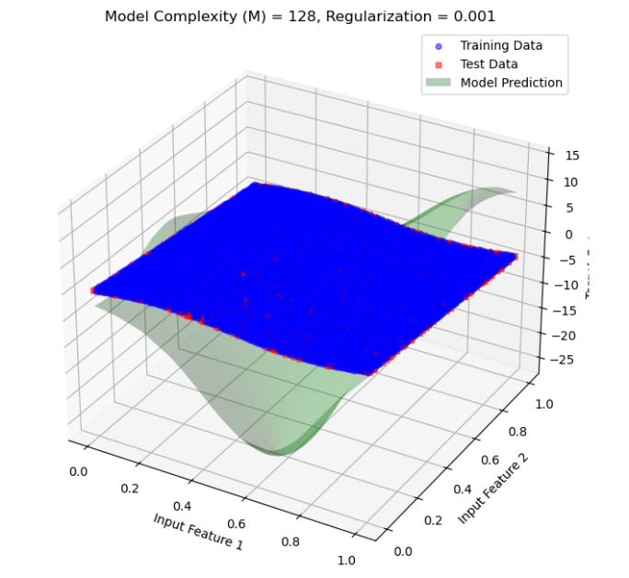
2. Regularization λ=0.001 (Low Regularization)
26figure

- Observation: A small amount of regularization slightly reduces overfitting by penalizing large weights. However, the model still exhibits significant overfitting, as the regularization strength is insufficient to manage the high complexity.
- Conclusion: Low regularization reduces overfitting marginally but does not significantly improve the model's ability to generalize, given the high complexity.

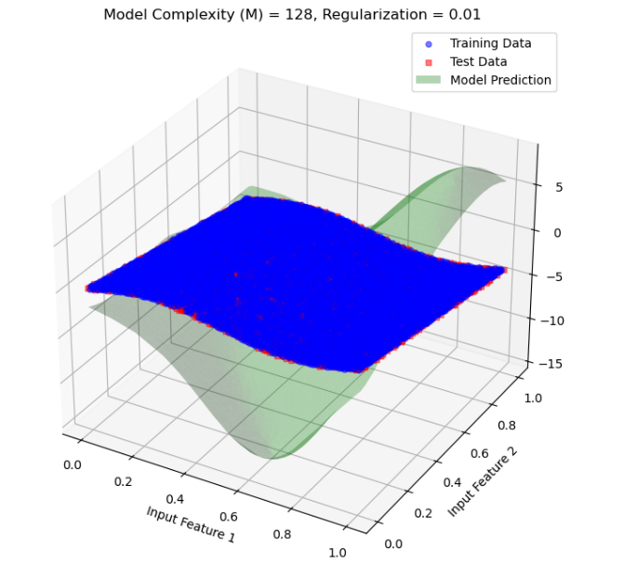
3. Regularization λ=0.01 (Moderate Regularization)
27figure

- Observation: Moderate regularization has a more noticeable effect, reducing overfitting further. The model’s generalization improves, but there may still be some signs of overfitting, as it may capture some minor noise in the data.
- Conclusion: Moderate regularization is effective at balancing the model’s complexity and smoothing its predictions, resulting in better performance on test data.

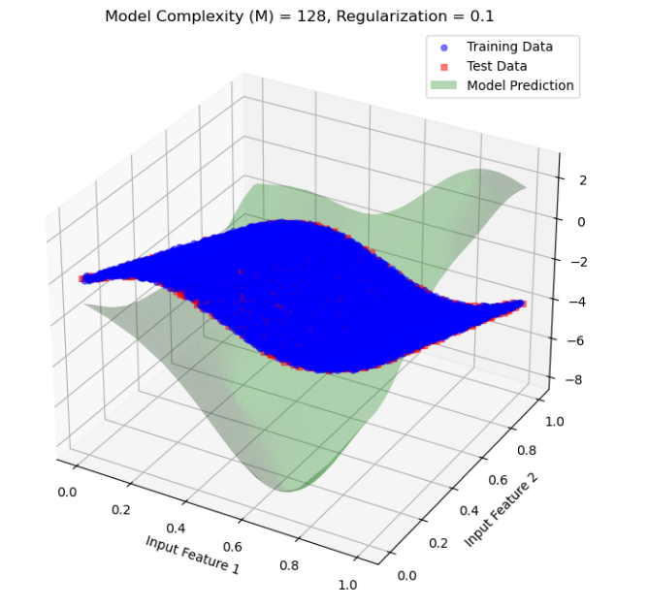
4. Regularization λ=0.1 (High Regularization)
28figure
- Observation: High regularization significantly constrains the model, causing it to generalize better. The model no longer captures minor fluctuations or noise within the training data, resulting in smoother and more generalizable predictions.
- Conclusion: High regularization provides a good balance, effectively reducing overfitting without causing the model to underfit drastically.

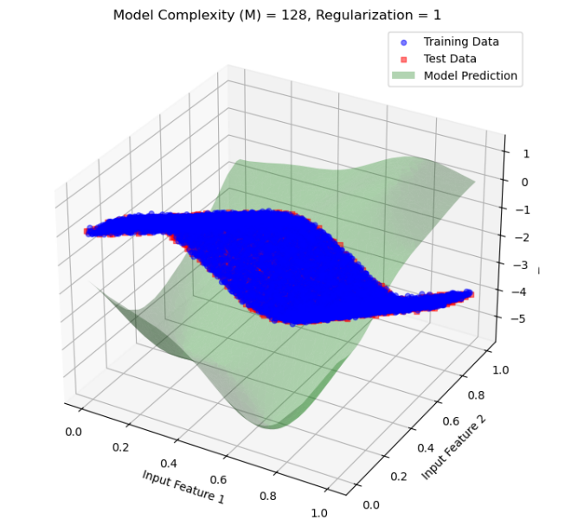
5. Regularization λ=1 (Very High Regularization)
29figure
- Observation: With very high regularization, the model starts underfitting as it becomes overly constrained. It fails to capture more subtle patterns in the data, resulting in poorer performance on both training and test data.
- Conclusion: Excessive regularization leads to underfitting, as the model becomes too simple to capture the complex structure in the data.

Interpretation: with model complexity 256
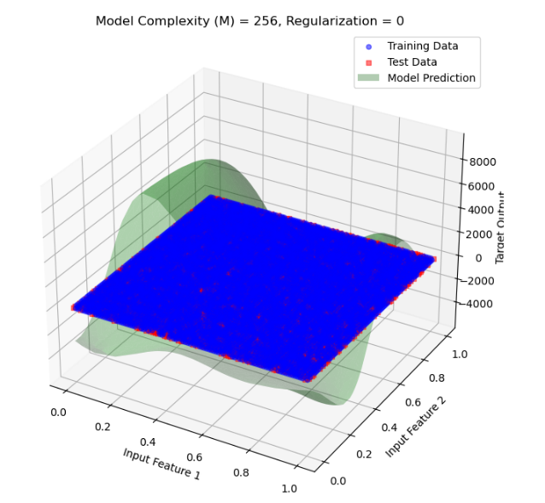
1.Regularization λ=0
30figure
- Observation: The prediction surface is highly irregular and oscillates significantly, fitting the training data almost exactly. This is a classic sign of overfitting.
- Inference: Without regularization, the model tries to minimize the error by fitting the noise in the training data. This leads to poor generalization, as it’s sensitive to fluctuations in the training set.

2.Regularization λ=0.001
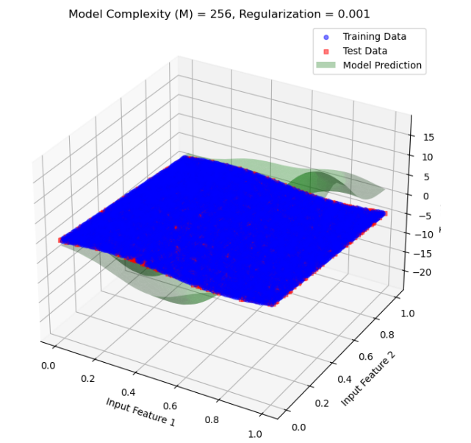
- Observation: Introducing a small amount of regularization has started to smooth the prediction surface. However, some overfitting effects still remain, as the model captures more detail than necessary.
31figure
- Inference: The model is now slightly penalized for having large coefficients, which reduces the flexibility just enough to avoid extreme fluctuations but still lacks full generalization.

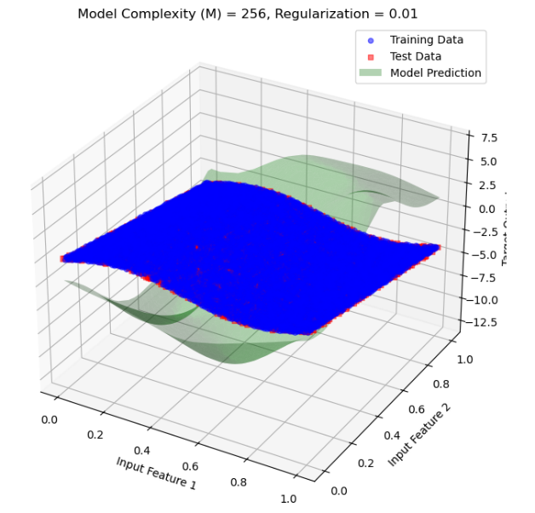
3.Regularization λ=0.01
32figure

- Observation: With a slightly higher regularization, the prediction surface is much smoother, indicating that the model is less sensitive to noise in the training data.
- Inference: This level of regularization strikes a better balance, allowing the model to generalize better by reducing overfitting without underfitting.

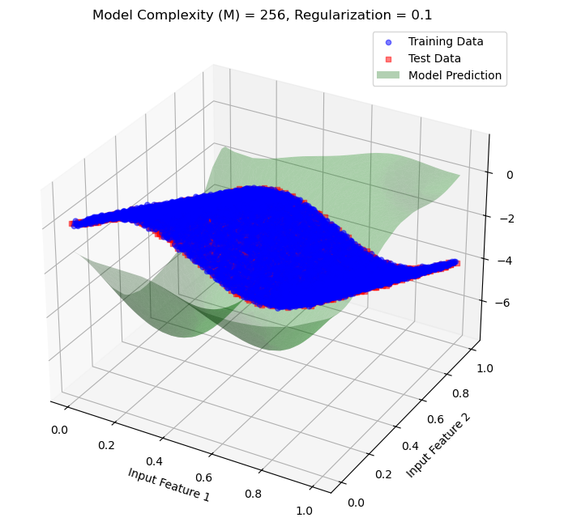
4.Regularization λ=0.1
33figure

- Observation: As the regularization parameter is increased further, the prediction surface becomes even smoother. The model now effectively generalizes, capturing the main trend without focusing on minor fluctuations in the training data.
- Inference: Regularization at this level reduces the likelihood of overfitting, providing a robust and generalized fit for both training and test data.

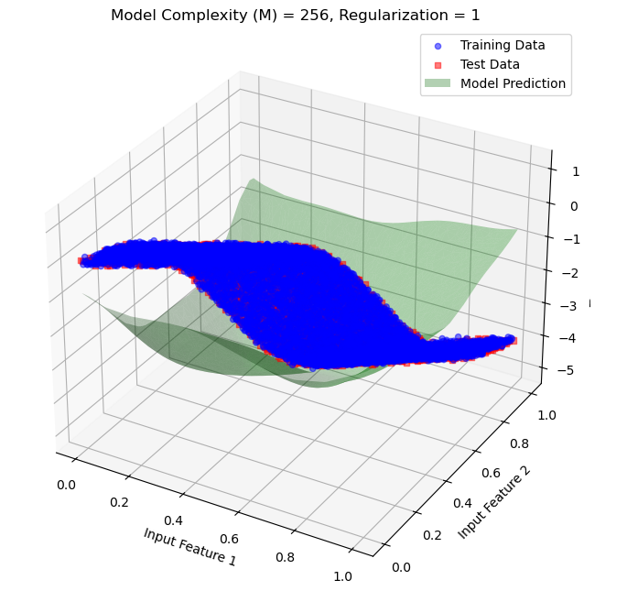
5.Regularization λ=1
34figure

- Observation: With a very high regularization parameter, the prediction surface becomes excessively smooth, and the model starts to underfit. It now captures only the general trend and lacks detail, which may lead to a poor fit on the training data.
- Inference: Regularization at λ=1 constrains the model’s 1accurately capture the true complexity of the data. This level of regularization leads to underfitting.

MSE:
1. MSE vs Model Complexity for Regularization Parameter =0

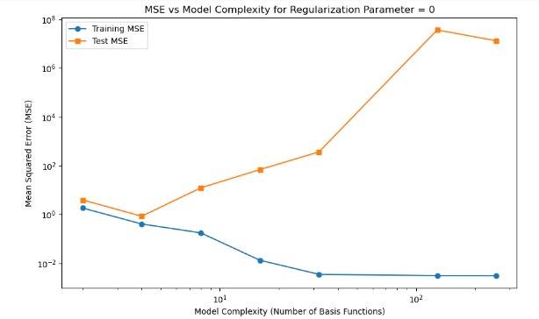
Observation & Inference:
- Training MSE: decreases consistently as model complexity increases, indicating better fit to training data.
• Test MSE: initially decreases with complexity but then sharply increases, showing overfitting at high complexities (e.g., 128, 256 basis functions).
• No Regularization: (λ = 0) allows the model to overfit, with a large gap between training and test MSE at high complexities.

35figure

2. MSE vs Model Complexity for Regularization Parameter = 0.001
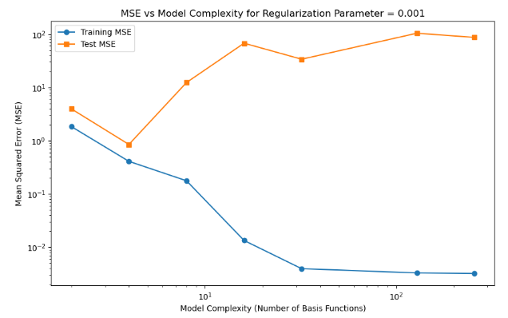
Observation & Inference:
- Training MSE: Decreases steadily with increasing model complexity, indicating a better fit to training data as complexity rises. Approaches a very low error at high complexities.
- Test MSE: Initially decreases, reaching a minimum around moderate complexities. Begins to increase at higher complexities, although the rise is less pronounced than with no regularization (from previous plots).
- Impact of Regularization (λ = 0.001): Regularization reduces overfitting compared to the unregularized case, with test MSE not increasing as sharply at high complexities.
36figure

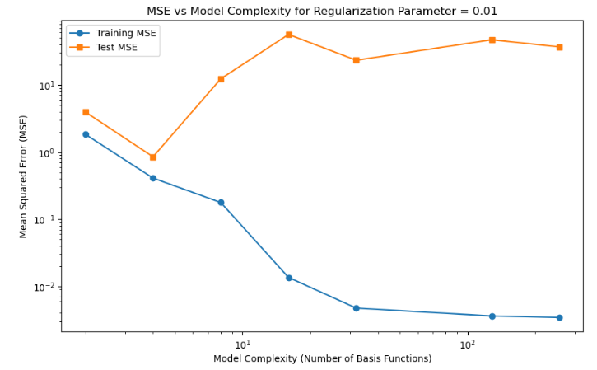
3. MSE vs Model Complexity for Regularization Parameter = 0.01
37figure
Observation & Inference:

  - Training MSE: Decreases with increasing model complexity, reaching a very low error at high complexities, indicating a better fit to training data.
  - Test MSE: Decreases initially, reaching a minimum at moderate complexities. Increases slightly at high complexities, but the rise is limited due to stronger regularization (λ = 0.01).
  - Regularization Impact (λ = 0.01): Regularization is more effective here, controlling the increase in test MSE at high complexities compared to lower regularization values.

4. MSE vs Model Complexity for Regularization Parameter = 0.1

38figure
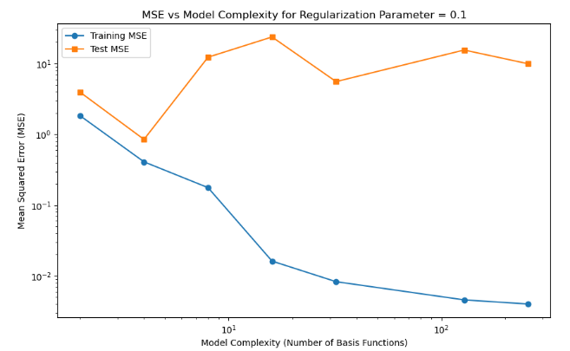
Observation & Inference:
- Training MSE: Continues to decrease with increasing model complexity, achieving very low error at high complexities.
- Test MSE: Shows less fluctuation at high complexities, but still reaches a minimum at moderate complexities. Higher regularization (λ = 0.1) smooths the increase in test MSE compared to lower regularization values.
- Regularization Impact (λ = 0.1) : This stronger regularization parameter more effectively controls overfitting, preventing large increases in test MSE even at high complexities.

5. MSE vs Model Complexity for Regularization Parameter = 1
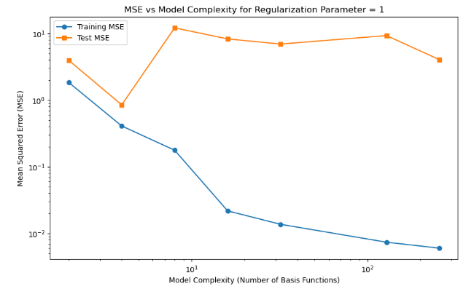
39 figure

Observation & Inference:
- Training MSE: Decreases steadily as model complexity increases, reaching very low values at high complexities.
- Test MSE: Shows minimal fluctuation and remains stable across various complexities, indicating a controlled level of generalization. Higher regularization (λ = 1) significantly limits overfitting, with test MSE staying relatively stable even as model complexity increases.
- Effect of Strong Regularization (λ = 1): The strong regularization effectively prevents overfitting, as evidenced by the minimal increase in test MSE at high complexities. The gap between training and test MSE is more consistent across complexities.

Output Plot:

1. Plot model output vs target output for training data
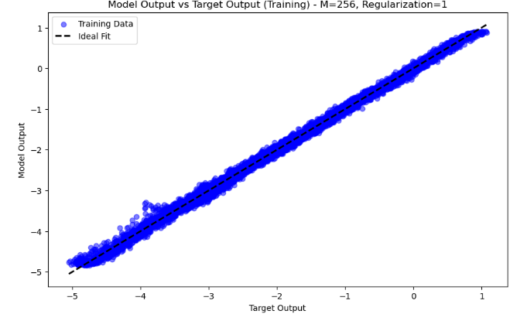
Observation :
- Model Output vs. Target Output: The model outputs closely align with the target outputs, as indicated by the clustering of points along the dashed ideal fit line (y = x).The data points form a narrow band around the ideal line, indicating accurate predictions on the training data.
- Complexity and Regularization: With a high complexity (M=256 basis functions) and strong regularization (λ=1), the model achieves a close fit without overfitting the noise.

Inference:
40 figure
- High Accuracy on Training Data: The model accurately captures the underlying pattern in the training data, suggesting that it effectively learned the data distribution.
- Controlled Overfitting: The strong regularization (λ = 1) helps prevent overfitting despite the high model complexity, maintaining alignment with the ideal fit line.

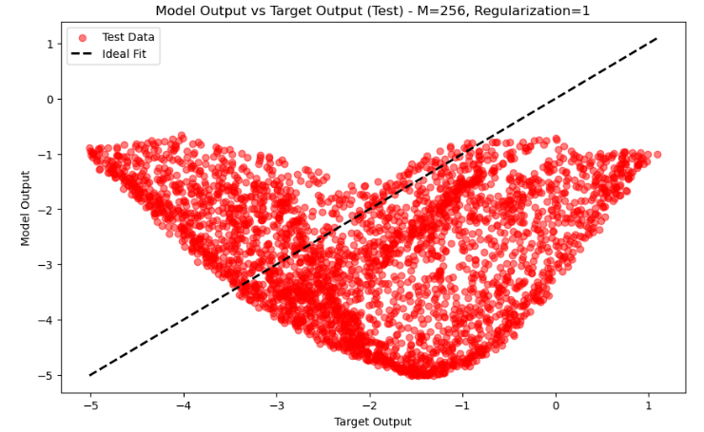
2. Plot model output vs target output for test data
Observation :
- Model Output vs. Target Output (Test Data): The test data points deviate significantly from the ideal fit line (y = x), showing a pronounced spread in a curved shape. The model output on the test set does not align well with the target output, indicating poor generalization.
- High Complexity and Regularization: Despite high model complexity (M=256) and strong regularization (λ=1), the model fails to generalize to the test data.
Inference:
41 figure
- Overfitting on Training Data: The model appears to have overfit the training data patterns, which do not generalize well to unseen test data.
- Model Instability: The mismatch between model output and target output on test data suggests that the model may be capturing noise or irrelevant patterns from the training data, despite regularization.

